Test 1

Car Speedometer

Prompt:
Create a complete HTML file with inline CSS and JavaScript that displays a cinematic car speedometer animation. The speedometer should look like the viewer is racing down a highway, with the needle smoothly accelerating and decelerating in a loop. Use a bold red and black racing theme with glowing neon effects. The design should look modern, high contrast, and dynamic. Center the speedometer on the page, and make sure it has a smooth animated speed needle, glowing tick marks, and an animated background that suggests movement or speed. The final code should be contained in one HTML file, ready to run in a browser.

Tested Models
Gemini, ChatGPT, Grok,

Grok:
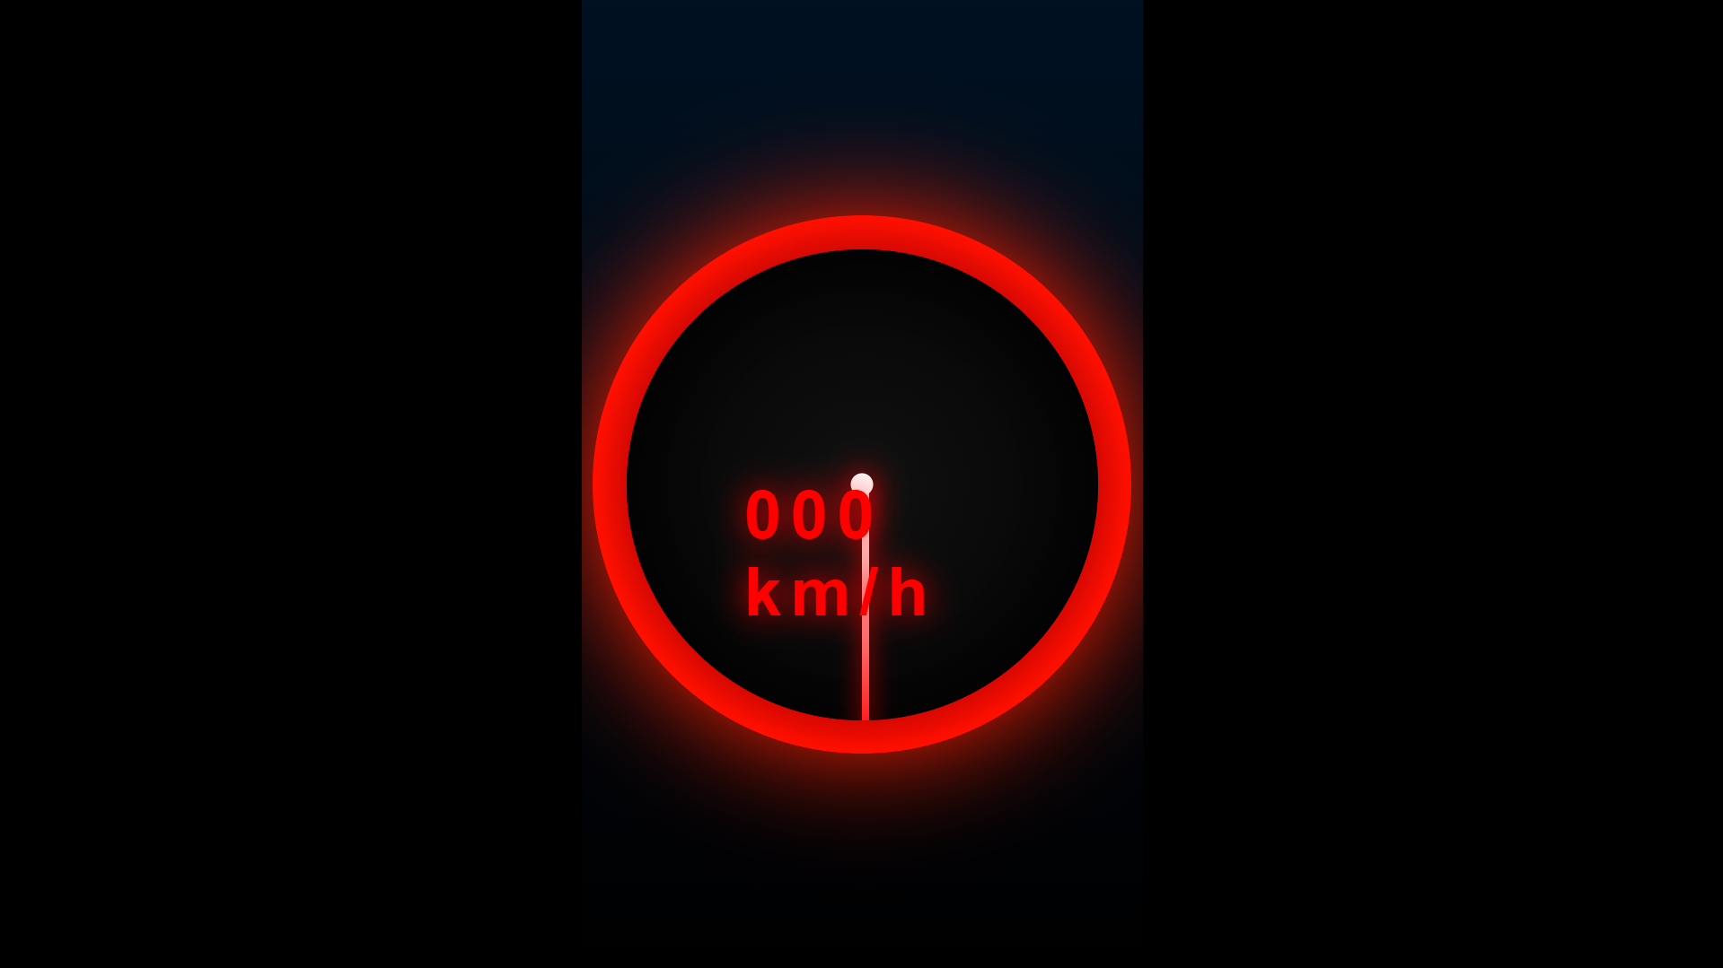

Code:
<!DOCTYPE html>
<html lang="en">
<head>
<meta charset="UTF-8">
<title>Cinematic Neon Racing Speedometer</title>
<meta name="viewport" content="width=device-width, initial-scale=1.0">
<style>
body, html {
margin: 0;
padding: 0;
height: 100%;
overflow: hidden;
background: #000;
display: flex;
align-items: center;
justify-content: center;
font-family: 'Arial', sans-serif;
perspective: 1000px;
}

/* Animated racing road background */
.background {
position: absolute;
top: 0; left: 0; width: 100%; height: 100%;
background: linear-gradient(to bottom, #001122 0%, #000000 100%);
overflow: hidden;
z-index: 1;
}

.road {
position: absolute;
bottom: 0;
width: 100%;
height: 100%;
background: repeating-linear-gradient(
0deg,
#111 0px,
,
#111 80px,
#ff2222 80px,
#ff2222 100px
);
animation: roadMove 0.8s linear infinite;
}

@keyframes roadMove {
0% { transform: translateY(0); }
100% { transform: translateY(-100px); }
}

.speedometer-container {
position: relative;
width: 500px;
height: 500px;
z-index: 10;
}

.speedometer {
position: relative;
width: 100%;
height: 100%;
}

/* Outer glow ring */
.outer-ring {
position: absolute;
width: 480px;
height: 480px;
top: 10px;
left: 10px;
border-radius: 50%;
background: radial-gradient(circle, transparent 45%, #ff0000 70%, #000 100%);
box-shadow:
0 0 60px #ff0000,
inset 0 0 60px #ff0000;
animation: pulse 4s infinite alternate;
}

@keyframes pulse {
0% { box-shadow: 0 0 60px #ff0000, inset 0 0 60px #ff0000; }
100% { box-shadow: 0 0 100px #ff2200, inset 0 0 100px #ff2200; }
}

/* Main gauge face */
.gauge {
position: absolute;
width: 420px;
height: 420px;
top: 40px;
left: 40px;
background: radial-gradient(circle, #111 0%, #000 100%);
border-radius: 50%;
box-shadow:
inset 0 0 80px #000,
0 0 40px rgba(255,0,0,0.6);
overflow: hidden;
}

/* Neon tick marks */
.ticks {
position: absolute;
width: 100%;
height: 100%;
}

.tick {
position: absolute;
width: 4px;
height: 30px;
background: linear-gradient(to top, #ff0000, #ff4444);
left: 50%;
top: 20px;
transform-origin: 50% 190px;
border-radius: 2px;
box-shadow: 0 0 15px #ff0000;
}

.tick.major {
height: 50px;
width: 6px;
box-shadow: 0 0 25px #ff0000;
}

/* Speed numbers */
.number {
position: absolute;
color: #ff3333;
font-size: 28px;
font-weight: bold;
text-shadow: 0 0 20px #ff0000;
transform: translate(-50%, -50%);
}

/* Needle */
.needle-base {
position: absolute;
width: 20px;
height: 20px;
background: #fff;
border-radius: 50%;
top: 50%;
left: 50%;
transform: translate(-50%, -50%);
box-shadow: 0 0 30px #ff0000;
z-index: 20;
}

.needle {
position: absolute;
width: 6px;
height: 240px;
background: linear-gradient(to top, #ff0000, #ffffff);
top: 50%;
left: 50%;
transform-origin: bottom center;
border-radius: 3px;
box-shadow: 0 0 20px #ff0000;
z-index: 15;
transition: transform 0.8s cubic-bezier(0.2, 0.8, 0.3, 1);
}

/* Digital speed display */
.digital {
position: absolute;
bottom: 80px;
left: 50%;
transform: translateX(-50%);
font-size: 60px;
font-weight: bold;
color: #ff0000;
text-shadow: 0 0 30px #ff0000;
letter-spacing: 8px;
z-index: 20;
}

20;
}

.unit {
font-size: 24px;
opacity: 0.8;
}

/* Particle speed lines */
.particles {
position: absolute;
width: 100%;
height: 100%;
pointer-events: none;
}

.particle {
position: absolute;
width: 4px;
height: 60px;
background: linear-gradient(to bottom, transparent, #ff4444);
opacity: 0;
animation: fly 2s linear infinite;
}

@keyframes fly {
0% { opacity: 0; transform: translateY(0) scaleY(0); }
20% { opacity: 1; }
100% { opacity: 0; transform: translateY(-800px) scaleY(3); }
}
</style>
</head>
<body>

<div class="background">
<div class="road"></div>
</div>

<div class="speedometer-container">
<div class="outer-ring"></div>
<div class="gauge">
<div class="ticks" id="ticks"></div>
<div class="needle-base"></div>
<div class="needle" id="needle"></div>
<div class="digital" id="digital">000 <span class="unit">km/h</span></div>
</div>
<div class="particles" id="particles"></div>
</div>

<script>
// Generate tick marks and numbers
const ticksContainer = document.getElementById('ticks');
const totalTicks = 24;
const maxSpeed = 300;

for (let i = 0; i <= totalTicks; i++) {
const angle = (i / totalTicks) * 270 - 135; // 270° arc from -135° to 135°
const tick = document.createElement('div');
tick.className = 'tick' + (i % 3 === 0 ? ' major' : '');
tick.style.transform = `rotate(${angle}deg)`;
ticksContainer.appendChild(tick);

);

// Add numbers every 3 ticks
if (i % 3 === 0) {
const num = document.createElement('div');
num.className = 'number';
const speedValue = Math.round((i / totalTicks) * maxSpeed / 10) * 10;
num.textContent = speedValue;
const rad = (angle * Math.PI) / 180;
const radius = 160;
num.style.left = `50%`;
num.style.top = `50%`;
num.style.transform = `translate(calc(-50% + ${Math.cos(rad) * radius}px), calc(-50% + ${Math.sin(rad) * radius}px)) rotate(${angle + 135}deg)`;
ticksContainer.appendChild(num);
}
}

// Needle animation loop
const needle = document.getElementById('needle');
const digital = document.getElementById('digital');
let currentSpeed = 0;
let targetSpeed = 0;
let accelerating = true;

function updateSpeed() {
// Smooth acceleration / deceleration cycle
if (accelerating) {
targetSpeed += 2;
if (targetSpeed >= 280) accelerating = false;
} else {
targetSpeed -= 1.5;
if (targetSpeed <= 0) accelerating = true;
}

// Smooth needle movement
currentSpeed += (targetSpeed - currentSpeed) * 0.08;
const angle = (currentSpeed / maxSpeed) * 270 - 135;
needle.style.transform = `translateX(-50%) rotate(${angle}deg)`;

// Update digital display
digital.innerHTML = Math.round(currentSpeed).toString().padStart(3, '0') + ' <span class="unit">km/h</span>';

requestAnimationFrame(updateSpeed);
}

updateSpeed();

// Add speed particles
const particlesContainer = document.getElementById('particles');
setInterval(() => {
if (currentSpeed > 100) {
for (let i = 0; i < 3; i++) {
const p = document.createElement('div');
p.className = 'particle';
p.style.left = Math.random() * 100 + '%';
p.style.animationDelay = Math.random() * 0.5 + 's';
p.style.animationDuration = (1 + Math.random()) + 's';
particlesContainer.appendChild(p);
setTimeout(() => p.remove(), 3000);
}
}
}, 200);
</script>

</body>
</html>

Gemini:
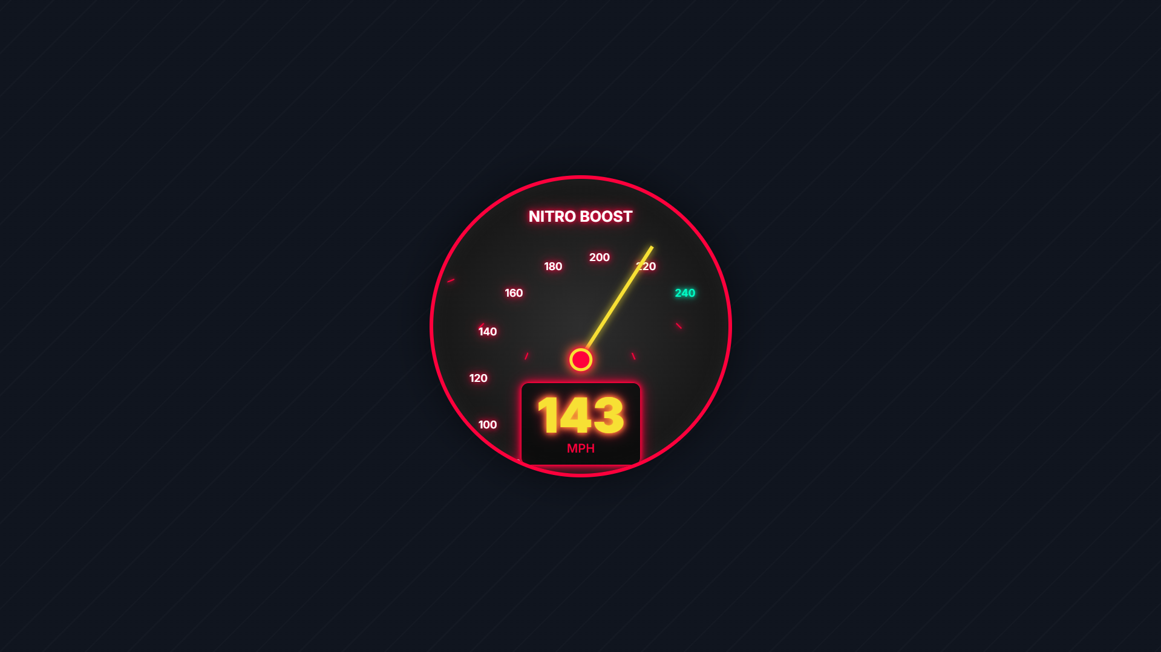

Code:

<!DOCTYPE html>
<html lang="en">
<head>
<meta charset="UTF-8">
<meta name="viewport" content="width=device-width, initial-scale=1.0">
<title>Cinematic Racing Speedometer</title>
<script src="https://cdn.tailwindcss.com"></script>
<style>
/* Load Inter font */
@import url('https://fonts.googleapis.com/css2?family=Inter:wght@100..900&display=swap');

:root {
--primary-red: #ff003c;
--secondary-black: #1a1a1a;
--dark-background: #0d0d0d;
--neon-glow: 0 0 5px var(--primary-red), 0 0 10px var(--primary-red), 0 0 20px rgba(255, 0, 60, 0.7);
--needle-color: #f7e034;
--needle-shadow: 0 0 10px #f7e034;
}

body {
font-family: 'Inter', sans-serif;
background-color: var(--dark-background);
display: flex;
justify-content: center;
align-items: center;
min-height: 100vh;
margin: 0;
overflow: hidden; /* Prevent scroll from background animation */
}

/* Cinematic Background Effect (Simulates motion) */
.cinematic-background {
position: fixed;
top: 0;
left: 0;
width: 200%; /* Wider than viewport for parallax/motion effect */
height: 100%;
/* Diagonal dark lines for speed/road effect */
background-image: repeating-linear-gradient(
-45deg,
var(--secondary-black) 0,
var(--secondary-black) 2px,
var(--dark-background) 2px,
var(--dark-background) 40px
);
animation: moveBackground 15s linear infinite;
z-index: -1;
opacity: 0.3;
}

@keyframes moveBackground {
from { transform: translateX(0); }
to { transform: translateX(-50%); }
}

.speedometer-container {
position: relative;
width: 400px;
height: 400px;
border-radius: 50%;
background: radial-gradient(circle at center, #2e2e2e 0%, var(--secondary-black) 60%, var(--dark-background) 100%);
box-shadow: 0 0 50px rgba(0, 0, 0, 0.5), inset 0 0 20px rgba(255, 255, 255, 0.05);
border: 5px solid var(--primary-red);
padding: 20px;
overflow: hidden;
}

.speedometer-dial {
position: relative;
width: 100%;
height: 100%;
border-radius: 50%;
}

/* Needle Styling */
.needle {
position: absolute;
bottom: 50%;
left: 50%;
width: 50%;
height: 5px;
transform-origin: 0% 50%;
/* Initial rotation for 0 MPH (135 degrees offset from vertical) */
transform: rotate(135deg);
background-color: var(--needle-color);
box-shadow: var(--needle-shadow);
z-index: 10;
transition: transform 0.1s linear; /* Smooth movement */
}

.needle::before {
content: '';
position: absolute;
top: -2px;
left: -10px;
width: 10px;
height: 9px;
background: var(--needle-color);
border-radius: 50%;
box-shadow: var(--needle-shadow);
}

.center-pin {
position: absolute;
top: 50%;
left: 50%;
transform: translate(-50%, -50%);
width: 30px;
height: 30px;
border-radius: 50%;
background: var(--primary-red);
border: 4px solid var(--needle-color);
box-shadow: var(--neon-glow), 0 0 15px var(--needle-color);
z-index: 15;
}

/* Tick Marks and Labels */
.tick-container {
position: absolute;
width: 100%;
height: 100%;
border-radius: 50%;
}

/* Function to generate dynamic tick marks (implemented in JS for complexity)
Here is the base style for a tick */
.tick {
position: absolute;
top: 50%;
left: 50%;
width: 2px;
height: 100%;
transform-origin: 0 0;
}

.tick span {
position: absolute;
display: block;
background: var(--primary-red);
box-shadow: var(--neon-glow);
width: 2px;
height: 10px;
top: -190px;
left: -1px;
border-radius: 1px;
}

.tick-label {
position: absolute;
color: #ffffff;
font-size: 14px;
font-weight: 600;
text-shadow: var(--neon-glow);
}

/* Digital Speed Display */
.speed-display {
position: absolute;
bottom: 10%;
left: 50%;
transform: translateX(-50%);
text-align: center;
color: var(--primary-red);
z-index: 20;
padding: 10px 20px;
background: rgba(0, 0, 0, 0.5);
border-radius: 10px;
border: 1px solid var(--primary-red);
box-shadow: var(--neon-glow);
}

#current-speed {
font-size: 4rem;
line-height: 1;
font-weight: 900;
color: var(--needle-color);
text-shadow: var(--needle-shadow), var(--neon-glow);
}

.units {
font-size: 1rem;
color: var(--primary-red);
font-weight: 600;
}

</style>
</head>
<body class="bg-gray-900">

<div class="cinematic-background"></div>

<div class="speedometer-container rounded-full">
<h1 class="text-white text-xl font-bold text-center pt-4" style="text-shadow: var(--neon-glow);">NITRO BOOST</h1>
<div class="speedometer-dial">

<!-- Dynamic Ticks and Labels will be inserted here by JavaScript -->
<div class="tick-container" id="tick-container"></div>

<div class="needle" id="speed-needle"></div>
<div class="center-pin"></div>

<div class="speed-display">
<div id="current-speed">000</div>
<div class="units">MPH</div>
</div>
</div>
</div>

<script>
// --- Speedometer Constants ---
const MIN_SPEED = 0;
const MAX_SPEED = 240;
const START_ANGLE = 135; // 0 MPH starting angle
const END_ANGLE = 45; // 240 MPH ending angle (clockwise)
const ARC_ANGLE = 360 - (START_ANGLE - END_ANGLE); // 270 degrees arc
const CENTER_X = 200; // Half of container width (400px)
const CENTER_Y = 200; // Half of container height (400px)
const RADIUS = 160;

// --- DOM Elements ---
const needle = document.getElementById('speed-needle');
const speedDisplay = document.getElementById('current-speed');
const tickContainer = document.getElementById('tick-container');

// --- Animation State ---
let currentTime = 0;
let lastTime = 0;
let targetSpeed = 0;
let currentSpeed = 0;
const maxAcceleration = 80; // Max speed change per second
const maxDeceleration = 60;

/**
* Maps a speed value to the corresponding rotation angle for the needle.
* The angle goes from 135deg (0 MPH) to 405deg (240 MPH).
* @param {number} speed - The current speed value.
* @returns {number} The rotation angle in degrees.
*/
function speedToAngle(speed) {
const ratio = (speed - MIN_SPEED) / (MAX_SPEED - MIN_SPEED);
// Angle range is 135deg to 405deg (135 + 270)
return START_ANGLE + (ratio * ARC_ANGLE);
}

/**
* Generates the speedometer tick marks and labels.
*/
function generateTicks() {
const majorTicks = 13; // 0, 20, 40, ..., 240
const step = (MAX_SPEED - MIN_SPEED) / (majorTicks - 1);

for (let i = 0; i < majorTicks; i++) {
const speedValue = i * step;
const angle = speedToAngle(speedValue);

// 1. Create the Tick Mark (Red Glow)
const tickEl = document.createElement('div');
tickEl.className = 'tick';
tickEl.style.transform = `translate(-50%, -50%) rotate(${angle}deg)`;

const span = document.createElement('span');
// Give special styling to the maximum speed tick
if (speedValue === MAX_SPEED) {
span.style.boxShadow = '0 0 10px #00ffc8, 0 0 20px #00ffc8, 0 0 30px #00ffc8';
span.style.backgroundColor = '#00ffc8';
span.style.height = '15px';
}
tickEl.appendChild(span);
tickContainer.appendChild(tickEl);

// 2. Create the Label (Speed Number)
const labelEl = document.createElement('div');
labelEl.className = 'tick-label';
labelEl.textContent = speedValue;

// Calculate position for the label (slightly outside the tick)
const labelAngleRad = (angle - 90) * (Math.PI / 180); // Adjust for CSS 0deg top
const labelX = CENTER_X + RADIUS * Math.cos(labelAngleRad);
const labelY = CENTER_Y + RADIUS * Math.sin(labelAngleRad);

// Center the label text around the calculated point
labelEl.style.left = `${labelX}px`;
labelEl.style.top = `${labelY}px`;
labelEl.style.transform = 'translate(-50%, -50%)';

// Give special styling to the maximum speed label
if (speedValue === MAX_SPEED) {
labelEl.style.color = '#00ffc8';
labelEl.style.textShadow = '0 0 5px #00ffc8, 0 0 10px #00ffc8';
}

tickContainer.appendChild(labelEl);
}
}

/**
* Randomly determines a new target speed for the needle to move towards.
*/
function setNewTargetSpeed() {
// Target speed bounces between high and low ranges for a cinematic effect
const isHighSpeed = Math.random() > 0.5;
if (isHighSpeed) {
targetSpeed = Math.floor(Math.random() * (MAX_SPEED - 180) + 180); // High speed burst
} else {
targetSpeed = Math.floor(Math.random() * (100 - 50) + 50); // Cruising speed
}
// Ensure target is within min/max bounds
targetSpeed = Math.max(MIN_SPEED, Math.min(MAX_SPEED, targetSpeed));
}

/**
* Main animation loop. Updates the speed and needle position smoothly.
* @param {number} timestamp - The current time in milliseconds.
*/
function animateSpeedometer(timestamp) {
if (lastTime === 0) {
lastTime = timestamp;
}
const deltaTime = (timestamp - lastTime) / 1000; // Delta time in seconds
lastTime = timestamp;

// Check if we need a new target
if (Math.abs(currentSpeed - targetSpeed) < 1) {
setNewTargetSpeed();
}

// Determine speed change based on acceleration/deceleration limits
let speedDelta = targetSpeed - currentSpeed;
let maxChange = 0;

if (speedDelta > 0) {
// Accelerating
maxChange = maxAcceleration * deltaTime;
} else {
// Decelerating (or braking)
maxChange = maxDeceleration * deltaTime;
}

// Apply change, capping it at the max allowed change for smoothness
if (Math.abs(speedDelta) > maxChange) {
speedDelta = speedDelta > 0 ? maxChange : -maxChange;
}

// Update the speed
currentSpeed += speedDelta;

// Clamp speed to boundaries
currentSpeed = Math.max(MIN_SPEED, Math.min(MAX_SPEED, currentSpeed));

// 1. Update Needle Rotation
const newAngle = speedToAngle(currentSpeed);
needle.style.transform = `rotate(${newAngle}deg)`;

// 2. Update Digital Display (Always show 3 digits)
const roundedSpeed = Math.round(currentSpeed);
speedDisplay.textContent = roundedSpeed.toString().padStart(3, '0');

requestAnimationFrame(animateSpeedometer);
}

// --- Initialization ---
window.onload = function() {
generateTicks();
setNewTargetSpeed(); // Start with an initial target speed
animateSpeedometer(0); // Start the main animation loop
};

</script>
</body>
</html>

ChatGPT:
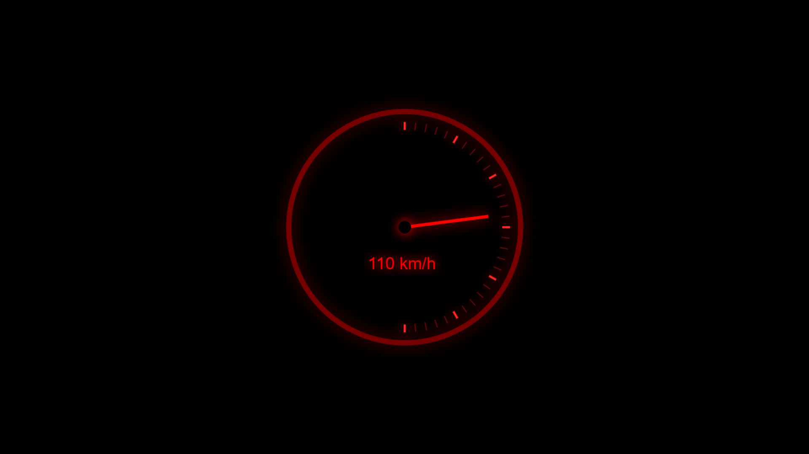

Code:
<!DOCTYPE html>
<html lang="en">
<head>
<meta charset="UTF-8">
<title>Cinematic Speedometer</title>
<style>
html, body {
margin: 0;
height: 100%;
background: #000;
overflow: hidden;
font-family: Arial, sans-serif;
}

/* Animated moving background */
body::before {
content: "";
position: fixed;
top: 0;
left: 0;
width: 200%;
height: 200%;
background: radial-gradient(circle at center, #222 0%, #000 70%) fixed,
repeating-linear-gradient(
90deg,
rgba(255,0,0,0.15) 0px,
rgba(255,0,0,0.15) 4px,
rgba(0,0,0,0) 4px,
rgba(0,0,0,0) 12px
);
animation: bgmove 5s linear infinite;
filter: blur(2px);
z-index: -1;
}

@keyframes bgmove {
0% { transform: translateX(0); }
100% { transform: translateX(-200px); }
}

/* Center speedometer container */
.container {
position: absolute;
top: 50%;
left: 50%;
transform: translate(-50%, -50%);
}

canvas {
display: block;
width: 500px;
height: 500px;
}
</style>
</head>
<body>

<div class="container">
<canvas id="speedometer" width="500" height="500"></canvas>
</div>

<script>
const canvas = document.getElementById("speedometer");
const ctx = canvas.getContext("2d");

const centerX = canvas.width / 2;
const centerY = canvas.height / 2;
const radius = 200;

let speed = 0;
let increasing = true;

// Draw glowing text
function glowText(text, x, y, size, color) {
ctx.font = size + "px Arial";
ctx.fillStyle = color;
ctx.shadowBlur = 20;
ctx.shadowColor = color;
ctx.fillText(text, x, y);
ctx.shadowBlur = 0;
}

// Draw speedometer
function drawSpeedometer() {
ctx.clearRect(0, 0, canvas.width, canvas.height);

// Outer glow ring
ctx.beginPath();
ctx.arc(centerX, centerY, radius + 20, 0, Math.PI * 2);
ctx.strokeStyle = "rgba(255,0,0,0.4)";
ctx.lineWidth = 10;
ctx.shadowBlur = 30;
ctx.shadowColor = "red";
ctx.stroke();
ctx.shadowBlur = 0;

// Tick marks
for (let i = 0; i <= 180; i += 6) {
const angle = (Math.PI * (i - 90)) / 180;
const inner = radius - 15;
const outer = radius;
const x1 = centerX + inner * Math.cos(angle);
const y1 = centerY + inner * Math.sin(angle);
const x2 = centerX + outer * Math.cos(angle);
const y2 = centerY + outer * Math.sin(angle);

ctx.beginPath();
ctx.moveTo(x1, y1);
ctx.lineTo(x2, y2);

ctx.strokeStyle = "rgba(255,40,40," + (i % 30 === 0 ? "1" : "0.3") + ")";
ctx.lineWidth = i % 30 === 0 ? 4 : 2;

ctx.shadowBlur = i % 30 === 0 ? 20 : 10;
ctx.shadowColor = "red";
ctx.stroke();
ctx.shadowBlur = 0;
}

// Needle
const needleAngle = (speed - 90) * (Math.PI / 180);
const needleLength = radius - 40;

ctx.beginPath();
ctx.moveTo(centerX, centerY);
ctx.lineTo(
centerX + needleLength * Math.cos(needleAngle),
centerY + needleLength * Math.sin(needleAngle)
);
ctx.strokeStyle = "red";
ctx.lineWidth = 6;
ctx.shadowBlur = 25;
ctx.shadowColor = "red";
ctx.stroke();
ctx.shadowBlur = 0;

// Center circle
ctx.beginPath();
ctx.arc(centerX, centerY, 12, 0, Math.PI * 2);
ctx.fillStyle = "black";
ctx.shadowBlur = 20;
ctx.shadowColor = "red";
ctx.fill();
ctx.shadowBlur = 0;

// Speed text
glowText(Math.floor((speed / 180) * 240) + " km/h", centerX - 70, centerY + 80, 32, "red");
}

// Animate needle acceleration and deceleration
function animate() {
if (increasing) {
speed += 0.7;
if (speed >= 180) increasing = false;
} else {
speed -= 0.7;
if (speed <= 0) increasing = true;
}

drawSpeedometer();
requestAnimationFrame(animate);
}

drawSpeedometer();
animate();
</script>

</body>
</html>

